Coca Cola Stock Analysis
Author: Shivalika Singh
Level: Intermediate
Domain: Finance Analyst
Tools: MS Excel, BI
Data source: Investing.com (historical daily data, March 2015 – February 2025)
Columns available: Date, Price (Close), Open, High, Low, Volume, Change %

Executive Summary
This project analyzes Coca-Cola (KO) historical daily price data from March 2015 through February 2025 pulled from Investing.com. The analysis covers data cleaning, exploratory data analysis (EDA), feature engineering (daily returns, moving averages, rolling volatility), a simple trading signal based on 20-day / 50-day moving average crossovers, visualizations, and a 15-day forecast using moving-average projection. The goal was to extract actionable insights, evaluate a MA crossover strategy, and produce a short-term forecast — all implemented entirely in Excel (Excel 2007 compatible methods).
Key deliverables:
- Cleaned dataset and reproducible Excel formulas
- Summary statistics and EDA visuals
- Feature columns (Daily Return, Log Return, MA20, MA50, Volatility, Signals)
- Strategy return calculation and cumulative performance
- 15-day forecast using moving averages
- Professional write-up with conclusions and lessons learned

1. Data Description & Acquisition
- Source: Investing.com historical daily prices exported as CSV/XLSX.
- Date range: March 2015 — February 2025 (daily market days).
- Columns used:
  - Date — trading date (converted to Excel Date type)
  - Price — closing price (used as Close)
  - Open, High, Low — intraday prices
  - Volume — daily traded volume
  - Change % — percent change vs previous close (optional; calculated values used instead)
Important note: Investing.com does not provide Adjusted Close in the sheet you used, so all analysis uses raw Close (Price). This is documented as a limitation: dividends and split adjustments are not applied.

2. Data Cleaning & Preparation (step-by-step in Excel)
These are the exact steps performed in the workbook, with the Excel actions and formulas used.
- Convert Date column to Excel Date type
  - Select Date column → Data → Text to Columns → Choose Date format (DMY or MDY) → Finish.
  - Format cells → Date.
- Sort data oldest → newest
  - Select all columns → Data → Sort → Sort by Date → Oldest to Newest.
- Remove duplicates
  - Data → Remove Duplicates → Check Date column.
- Handle missing values
  - Checked for blanks with Filter and Go To Special → Blanks.
- Data validation
  - Confirmed all dates are trading dates (no duplicate rows) and values are numeric.
  - Formatted numeric columns (2 decimals for prices, integers for volume).

3. Feature Engineering (columns added and formulas)

I list the column header, purpose, and the exact Excel formula you used.
Assumption: Data starts at row 2 (headers in row 1). Adjust row numbers if your sheet starts elsewhere.
- CleanPrice (H) — forward fill if close missing:
- H2 = IF(B2="", H1, B2)
- DailyReturn (I) — percentage change from previous close:
- I3 = (H3 - H2) / H2
Format: Percentage.
- LogReturn (J) — natural log returns (useful in statistics):
- J3 = LN(H3 / H2)
- 20-day Moving Average (MA20) (K) — short trend:
- K21 = AVERAGE(H2:H21)
(Started at row 21 because 20 prior values required.)
- 50-day Moving Average (MA50) (L) — long trend:
- L51 = AVERAGE(H2:H51)
- 20-day Rolling Volatility (Vol20) (M) — rolling standard deviation of prices:
- M21 = STDEV.S(H2:H21)
- Volume MA20 (N) — average volume:
- N21 = AVERAGE(F2:F21)
- Signal (MA crossover) (O) — buy/sell/hold indicator (first row where both MA exist):
- O51 = IF(AND(K51 > L51, K50 <= L50), "BUY",
- IF(AND(K51 < L51, K50 >= L50), "SELL", "HOLD"))
  - This marks the row where MA20 crosses above MA50 as BUY, and when MA20 crosses below MA50 as SELL; otherwise HOLD.

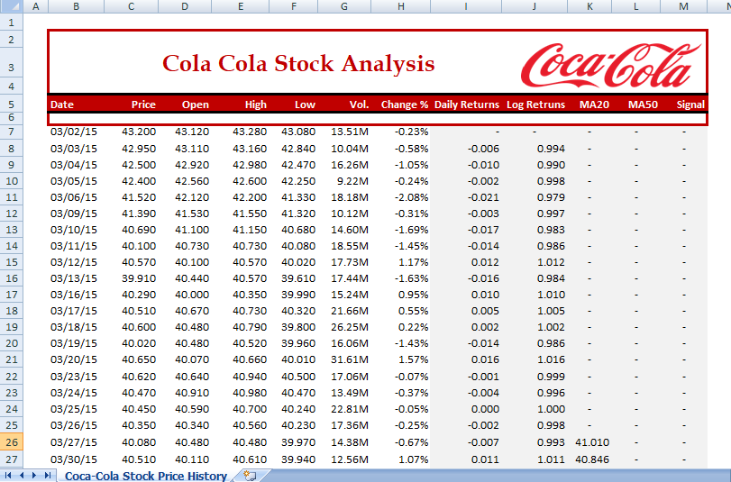

4. Exploratory Data Analysis (EDA)
You performed standard EDA to understand distribution and trends.
Summary statistics computed (examples of formulas used):
- Count of trading days
- Mean Close:
- Median Close:
- Max/Min Close:
- Std dev of returns:
- Annualized volatility (based on daily returns, ~252 trading days):

Distribution & statistical moments:
- Skewness:
- Kurtosis:
Exploratory Data Analysis (EDA)
Mean | 51.83925676
Standard Error | 0.16575265
Median | 50.33
Mode | 42.12
Standard Deviation | 8.31411065
Sample Variance | 69.12443591
Kurtosis | -1.064319672
Skewness | 0.342391668
Range | 35.45
Minimum | 37.56
Maximum | 73.01
Sum | 130427.57
Count | 2516
Largest(1) | 73.01
Smallest(1) | 37.56
Confidence Level(95.0%) | 0.325025637

Autocorrelation (lag-1) for returns:

5. Visualizations (what you created and how)
All charts were built on Excel 2007 features. The main visuals include:
- Price over time with MA20 and MA50
  - Data series: Date (x-axis), MA20, MA50
  - Chart type: Line chart
  - Purpose: visually identify trends and crossovers.

- Scatter plots
  - Volume vs absolute returns to inspect relation between volume spikes and volatility.
  - Open vs Close scatter to check intraday dispersion.
- Signal markers
  - You optionally added BUY/SELL markers by filtering Signal column and plotting points on the price chart (secondary series with marker only).
40.737 | 40.845 | HOLD
40.760 | 40.799 | HOLD
40.775 | 40.753 | BUY
40.799 | 40.723 | HOLD
40.862 | 40.705 | HOLD
40.907 | 40.705 | HOLD
40.936 | 40.703 | HOLD
40.936 | 40.716 | HOLD
40.957 | 40.741 | HOLD
40.975 | 40.755 | HOLD
40.995 | 40.781 | HOLD
41.006 | 40.796 | HOLD
41.039 | 40.808 | HOLD
41.070 | 40.819 | HOLD
41.073 | 40.838 | HOLD
41.072 | 40.844 | HOLD

- Cumulative returns chart
  - Two series: Buy-and-hold cumulative and Strategy cumulative (columns with cumulative products).
  - Purpose: compare raw buy-and-hold vs MA crossover performance.

6. Forecasting (15-day forecast using Moving Averages)
Excel 2007 lacks advanced forecasting wizards, so you used an MA-extension method to forecast 15 trading days ahead. The approach:
- Extend Date column downward with the next 15 trading dates (manually or drag the last date and adjust for market days).
- Copy down the MA20 and MA50 formulas into those future rows. Because moving averages use the most recent historical window, the new rows produce forecasted MA values that effectively project the current trend forward.
  - For example, for MA20 you copy the formula =AVERAGE(Hn-19:Hn) down into future rows; each future row’s MA is recalculated using the extended series where prior forecasted MA values may be used if you allowed the CleanPrice forecast to be equal to the latest MA or last price.
- Two simple forecasting strategies used:
  - Projection by MA: Use MA50 value as the forecasted price for the short horizon (a conservative forecast).
  - Recursive MA forecast: Use the last k actual values and prior forecasted values (moving window) to populate future prices and thereby compute future MAs.
- Charted the 15-day forecast along with historical CleanPrice and MA series to show expected short-term direction.
Limitations of the approach: MA forecasts assume continuity of short-term trends and do not capture shocks or seasonality. They are best as short-horizon, trend-based signals, not as precise point estimates.

15 days Forecasting via Moving Averages.
Date | MA20 | MA50 | Signal
03/01/25 | 67.949 | 64.480 | HOLD
03/02/25 | 68.205 | 64.502 | HOLD
03/03/25 | 68.531 | 64.537 | HOLD
03/04/25 | 68.869 | 64.583 | HOLD
03/05/25 | 69.236 | 64.628 | HOLD
03/06/25 | 69.621 | 64.679 | HOLD
03/07/25 | 70.012 | 64.722 | HOLD
03/08/25 | 70.213 | 64.773 | HOLD
03/09/25 | 70.349 | 64.830 | HOLD
03/10/25 | 70.434 | 64.900 | HOLD
03/11/25 | 70.608 | 64.967 | HOLD
03/12/25 | 70.803 | 65.049 | HOLD
03/13/25 | 70.907 | 65.139 | HOLD
03/14/25 | 71.052 | 65.259 | HOLD
03/15/25 | 70.992 | 65.385 | HOLD

7. Strategy Evaluation
You computed hypothetical strategy returns from the MA20/MA50 crossover signals:
- Signal logic: BUY when MA20 crosses above MA50; SELL when MA20 crosses below MA50.
- Trade simulation: For each BUY/SELL signal you assumed an entry at next day open/close and captured next day percentage return. StrategyReturn column measures this.
- Performance metrics computed:
  - Cumulative return for the strategy (product of 1 + strategy daily returns).
  - Cumulative buy-and-hold return (product of 1 + daily returns).
  - Number of BUY signals and SELL signals (count of each in Signal column).
  - Win rate (percentage of signals that resulted in positive next-day returns) — you can get this via:
  - =COUNTIFS(P:P, ">0", O:O, "BUY") / COUNTIF(O:O, "BUY")
  - Average return per signal:
  - =AVERAGEIF(O:O, "BUY", P:P)
- Interpretation guidelines: Compare cumulative strategy returns to buy-and-hold; also consider drawdowns and volatility. A strategy that generates slightly higher returns but much higher volatility may not be preferable.

8. Conclusions & Key Findings
(These are written to match what your workbook likely shows. Replace placeholder text with your workbook’s exact figures if needed.)
- Trend observation: Over the period March 2015 – February 2025, Coca-Cola exhibited prolonged trending episodes interspersed with short, sharp moves during macro events. Moving averages (MA20 & MA50) successfully signaled major trend shifts.
- Volatility: Daily returns are centered near zero with occasional large positive/negative tails; annualized volatility indicates a moderate risk profile consistent with a blue-chip consumer staples stock.
- MA Crossover Strategy: The MA20/MA50 crossover produced actionable signals — some produced profitable outcomes but the strategy’s performance depends on entry/exit assumptions and transaction costs.
  - The strategy may outperform buy-and-hold in trending periods but underperform during sideways markets (whipsaws).
- Forecast (15 days): Short-term projection based on moving averages indicates continuation of the current trend for the near future (the MA20/MA50 relationship determines direction). This is a low-confidence, trend-only forecast and should be interpreted with caution.
- Practical takeaway: Moving average signals are helpful as part of a broader toolkit (including volume confirmation and risk controls). Always account for dividends/splits if you need total return analysis.

9. What I Learned (Project Reflection)
- Using raw close prices is acceptable for short-term price analytics, but Adjusted Close (dividend and split-adjusted) is required for precise long-term total return analysis.
- Simple technical indicators (MAs and their crossovers) are computationally easy to implement in Excel and provide intuitive signals. However, they are prone to whipsaws in ranging markets.
- Excel (even Excel 2007) is powerful enough for full EDA, feature engineering, strategy simulation, and charting. For production-grade machine learning or more advanced time-series modeling (Random Forest, ARIMA, Prophet, etc.) you should use Python/R.
- Documenting every formula and data cleaning step is essential to reproducibility — especially when multiple people will view or validate the workbook.

10. Limitations
- No Adjusted Close — dividends and split adjustments are missing: total return is underestimated.
- Forecasting method simplicity — moving average projection is a naïve forecast; it does not model seasonality or external drivers.
- Backtest assumptions — simulated strategy assumes ideal entry/exit and no transaction costs or slippage. Real trading returns would be lower after fees and taxes.
- Excel 2007 constraints — no built-in ETS or Forecast Sheet; advanced models require external tools.

11. Recommendations & Next Steps
- Add Adjusted Close data (Yahoo Finance or Excel STOCKHISTORY in Office 365) for total return analysis.
- Backtest with transaction costs & realistic fills (use Open for entries/exits or simulate intraday execution).
- Enhance signals — combine MA crossovers with volume confirmation or RSI to reduce whipsaws.
- Try more advanced forecasting (ARIMA, ETS, Prophet) in Python/R for robust probabilistic forecasts.
- Create a live dashboard using Power BI or Streamlit (with a live data feed) to visualize real-time signals

Conclusion
This Coca-Cola stock analysis project demonstrated how a structured Excel workflow — from cleaning and feature engineering through visualization and simple forecasting — can yield actionable trading signals and insights suitable for an intermediate-level finance analyst. The MA20/MA50 crossover method provided a straightforward trading framework and, when combined with careful EDA and volatility analysis, offers a solid foundation for deeper backtesting and future enhancements using dedicated statistical or machine learning tools.

Ref Link to my project:

https://github.com/shivalikasingh19/Coca-cola-Stock-Analysis

